**Lab Practical #09:**

Study Packet capture and header analysis by Wireshark (HTTP, TCP, UDP, IP, etc.)

**Practical Assignment #09:**

1. **Explain usage of Wireshark tool.**
2. **Packet capture and header analysis by Wireshark (HTTP, TCP, UDP, IP, etc.)**

**Ans-1:**

* Wireshark is a free open-source tool that analyzes network traffic in real-time for Windows, Mac, Unix, and Linux systems. It captures data packets passing through a network interface (such as Ethernet, LAN, or SDRs) and translates that data into valuable information for IT professionals and cybersecurity teams.

**Ans-2:**

* **HTTP (Hypertext Transfer Protocol)**

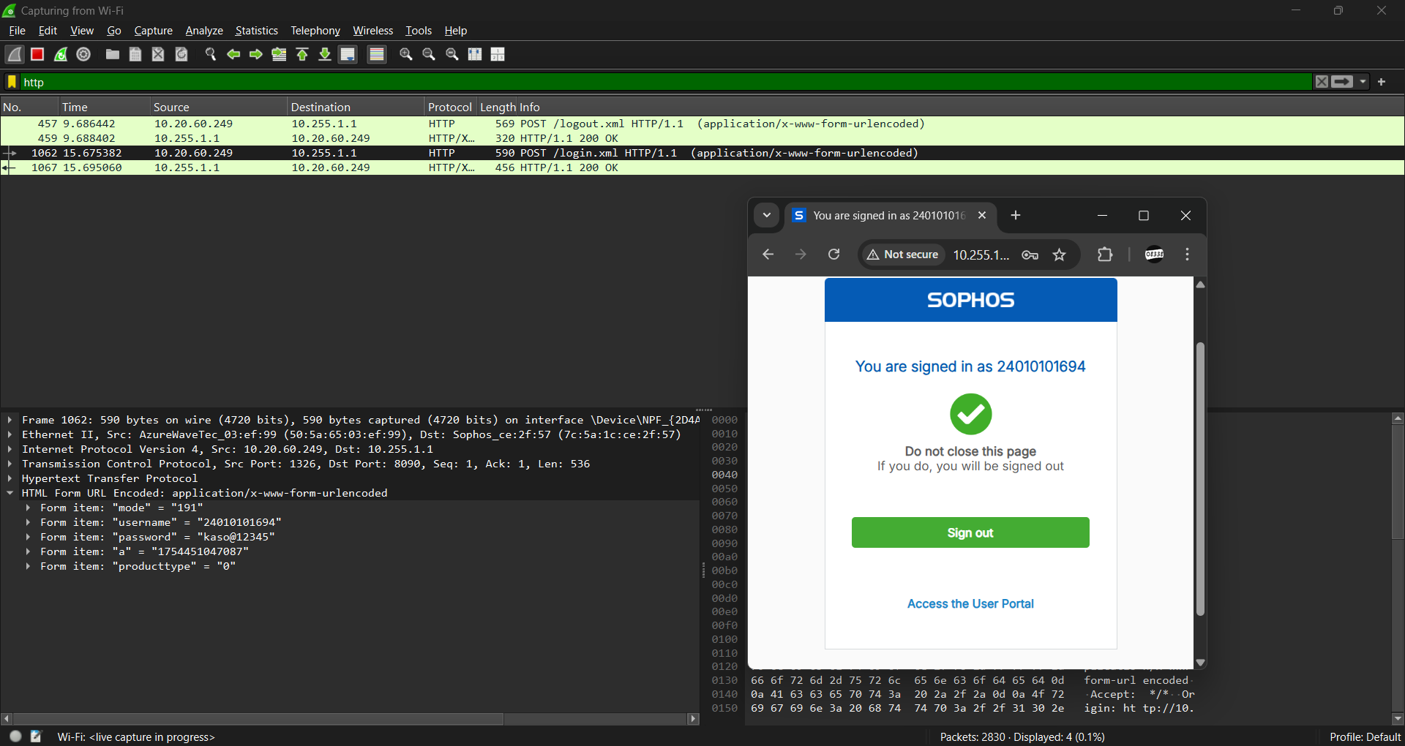

* **IP (Internet Protocol)**

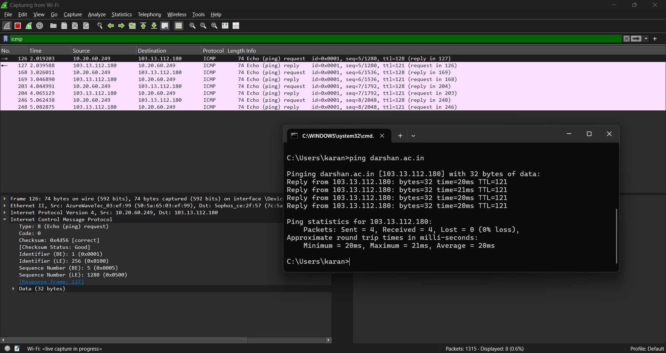

* **TCP (Transmission Control Protocol)**

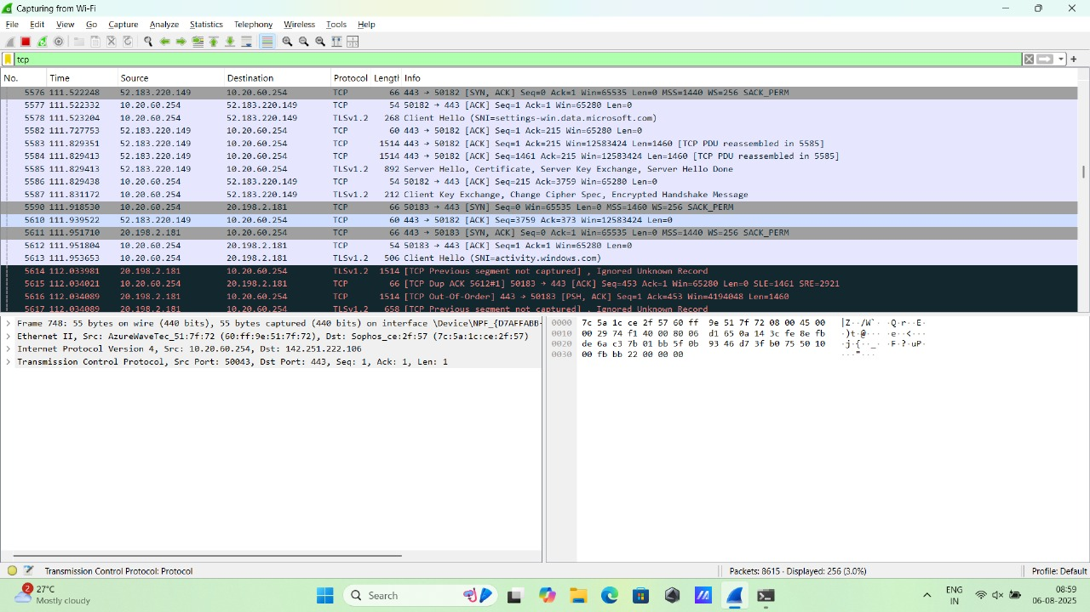

* **UDP (User Datagram Protocol)**

